www.mmivf.co.uk
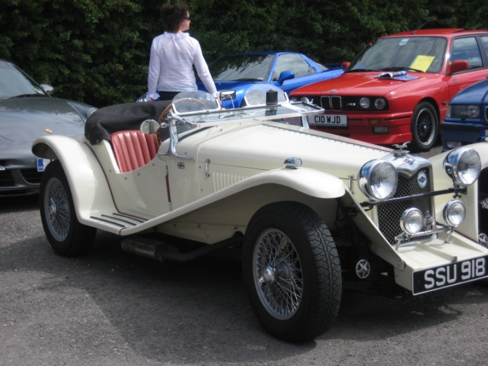
Sunday August 17th 2014

Mark Village Hall Somerset TA94NY

Show Vehicles Enter from 9.00am.

Event opens 11.00am
Refreshments include Delicious Food and Bar.

Contact Bruce & Julie at 01 278 641 509 bruce.penrose@googlemail.com

